 | 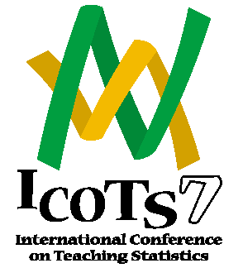 | 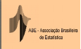

Working Cooperatively in Statistics Education

Salvador (Bahia), Brazil, July 2-7, 2006

http://www.maths.otago.ac.nz/icots7

Call for Papers
The 2006 Conference will be held in the city of Salvador, in the state of Bahia, Brazil, July 2-7. It will be organised by the IASE and the Brazilian Statistical Association (ABE), with support of the Brazilian Institute of Geography and Statistics (IBGE).
Statistics educators, statisticians, teachers and educators at large are invited to contribute to the scientific programme. Types of contribution include invited papers, contributed papers and posters. No person may author more than one Invited Paper at the conference, although the same person can be co-author of more than one paper, provided each paper is presented by a different person.
Voluntary refereeing procedures will be implemented for ICOTS7. Details of how to prepare manuscripts, the refereeing process and final submission arrangements will be announced later.

Invited Papers
Invited Paper Sessions are organized within 9 different Conference Topics 1 to 9. The list of Topic and Sessions themes, with email contact for Session Organisers is available at the ICOTS-7 web site at http://www.maths.otago.ac.nz/icots7, under “Scientific Programme”. Those interested in submitting an invited paper should contact the appropriate Session Organiser before December 1, 2004.

Contributed Papers
Contributed paper sessions will be arranged in a variety of areas. Those interested in submitting a contributed paper should contact either Joachim Engel (Engel_Joachim@ph-ludwigsburg.de) or Allan MacLean (alan.mclean@buseco.monash.edu.au) before September 1, 2005.

Posters
Those interested in submitting a poster should contact Celi Lopes (celilopes@uol.com.br) before February, 1, 2006.

General issues
It is important for you to know that all participants have to register for the Conference. Details about the registration procedure will be given later.
If requested, the IASE is normally happy to give permission for authors to submit their papers (or a more comprehensive version) to other journals, such as Statistics Education Research Journal, Journal of Statistics Education, International Statistical Review or Teaching Statistics. If this occurs the author must seek approval of the editors of the ICOTS7 Proceedings and the IASE President. The paper must have an acknowledgement saying "This article was written for, and published in, the ICOTS7 Proceedings and is reprinted (in revised form, if relevant) here with the permission of the IASE".

More information is available from the ICOTS-7 web site at http://www.maths.otago.ac.nz/icots7 or from the ICOTS IPC Chair Carmen Batanero (batanero@ugr.es), the Programme Chair Susan Starkings (starkisa@lsbu.ac.uk) and the Scientific Secretary John Harraway (jharraway@maths.otago.ac.nz).

